**Finlay, Ian Hamilton (1925-2006).**

Scottish poet and artist, known chiefly for his CONCRETE POETRY and his garden in southern Scotland ‘Little Sparta’, in which language, sculpture, tradition and landsca­­pe are fused with a playful wit and neoclassical rigour.

Poet, artist, and self-described ‘avant-gardener’ Ian Hamilton Finlay is best known for his CONCRETE POETRY of the 1960s and a number of ambitious outdoor works that fuse language, sculpture and landscape. The most famous of these is his poetry garden ‘Little Sparta’ at Stonypath, in the Pentland hills of southern Scotland, where he lived and worked from 1966 until his death.

Finlay was born in the Bahamas to Scottish parents. He was sent to boarding school at Dollar Academy, Stirling, aged six, and later briefly attended Glasgow School of Art. He joined the Non-Combatant Corps in the latter part of the Second World War, visiting Holland and Germany. During the 1950s he wrote short stories, plays and lyric poetry whilst working as a shepherd and casual labourer throughout Scotland, most notably in the Orkney Islands, after which time the fishing-boat becomes a recurrent theme of his work. In 1961 he founded the Wild Hawthorn Press, primarily as a vehicle for his own work, and published *Glasgow Beasts, An A Burd,* a series of playful lyrics in Glaswegian dialect modelled after the Japanese *tanka*. In 1962 he discovered CONCRETE POETRY and founded the influential poetry magazine *Poor. Old. Tired. Horse.* (1962-1967), which played a significant role introducing such work to an English-speaking audience. His first collection of CONCRETE POETRY *Rapel* (1963) defines an aesthetic combining a superficial playfulness with serious imaginative depth, wherein formal ambition is tempered by a sensibility at once both classical and modern. His later work of the 1960s and beyond largely eschews the conventional book format in order to produce highly crafted ‘poem-objects’ and ‘poem-prints’ such as *Sea-Poppy 2* (1968).

At Stonypath, Finlay, in collaboration with his second wife Sue and numerous craftsmen, began work on the garden that remains his *magnum opus*, a five-acre site containing over 275 sculptures and inscriptions that meditate on the relationship between nature and culture. Classical mythology, the French Revolution, and literary and art history are key themes. It was renamed Little Sparta in 1983 following a dispute with the regional authorities over rates, one of several high-profile disputes throughout his career. A singular achievement of twentieth century poetry, sculpture and landscape design, it has contributed – along with the prolific output of the Wild Hawthorn Press and a number of exhibitions – to international recognition in literature and the visual arts.

**List of Works**

Wild Hawthorn Press publications are rare and prohibitively expensive. Fortunately, a number of collections have been published, listed below.

*Ian Hamilton Finlay: Selections* (2012) ed. Alec Finlay,Berkeley: University of California Press.

*The Dancers Inherit the Party: Early Stories, Plays and Poems* (2004) ed. Alec Finlay,Edinburgh: Polygon.

*Prints: 1963-1997* (1997) ed. Pia Simig,Ostfildern: Cantz Verlag.

**References and Further Reading**

Abrioux, Yves (1985, 1992) *Ian Hamilton Finlay: A Visual Primer* London: Reaktion

Finlay, Alec (ed.) (1995) *Wood Notes Wild: Essays on the Poetry and Art of Ian Hamilton Finlay* Edinburgh: Polygon

Sheeler, Jessie (2003) *Little Sparta: The Garden of Ian Hamilton Finlay* London: Francis Lincoln Ltd.

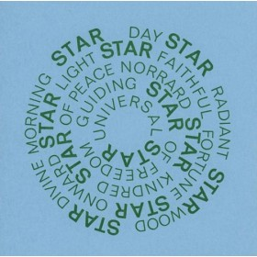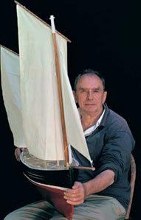

Portrait from Wikipedia <en.wikipedia.org/wiki/File:Portrait_of_Ian_Hamilton_Finlay.jpg>

*Sea-Poppy 2* from Ingleby Gallery (attach by second paragraph of main entry) <<http://ingleby.culturelabel.com/sea-poppy-2.html>>

**Calum Rodger, University of Glasgow**